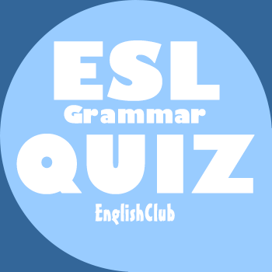

Infinitive or -ing Quiz https://www.englishclub.com/grammar/verbs-m_infinitive-ing_quiz.htm
You can do this grammar quiz online or print it on paper. It tests what you learned on the Infinitive or -ing? page.

1. We like ________ our grandmother on Sundays.
to visit
visiting
to visit/visiting
2. I might want ________ some money soon.
to borrow
borrowing
to borrow/borrowing
3. My father hates ________ a tie to work.
to wear
wearing
to wear/wearing
4. We can't afford ________ a vacation this summer.
to take
taking
to take/taking
5. The company was pleased ________ your thank-you letter.
to receive
receiving
to receive/receiving
6. Would you mind ________ a window?
to open
opening
to open/opening
7. My suitcase is light enough ________ this time.
to carry
carrying
to carry/carrying
8. She cannot leave the table without ________ her dinner.
to finish
finishing
to finish/finishing
9. The music will continue ________ until you turn it off.
to play
playing
to play/playing
10. My little brother dislikes ________ his hair brushed.
to have
having
to have/having

