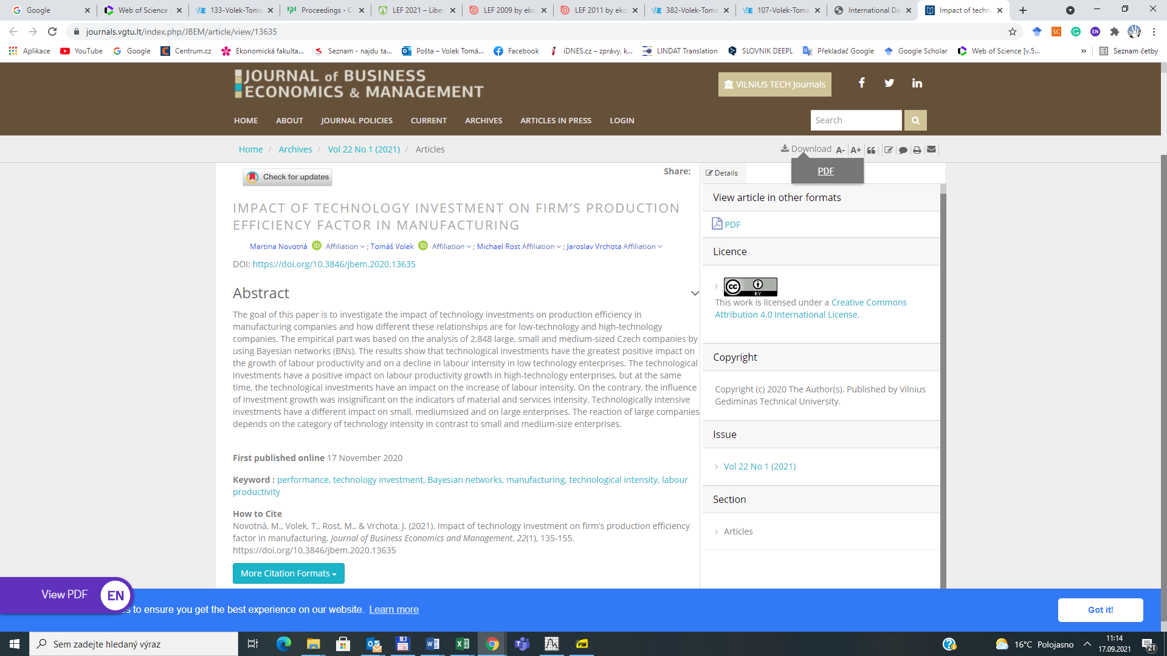

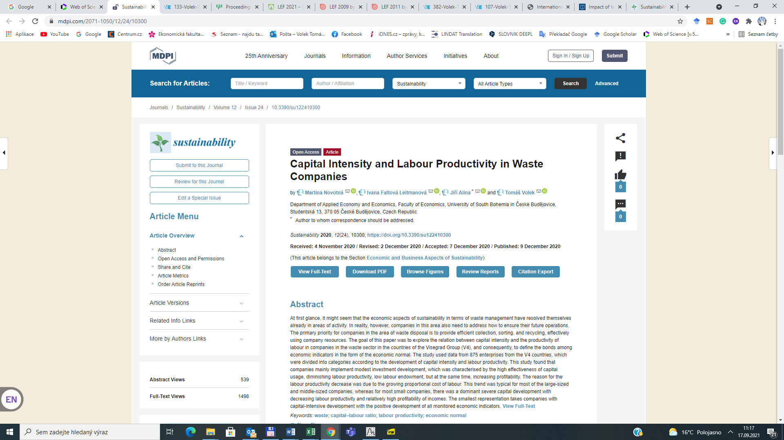

**SEZNAM ČLÁNKŮ J IMP**

Novotná, M., Volek, T., Rost, M., & Vrchota, J. (2021). Impact of technology investment on firm’s production efficiency factor in manufacturing. *Journal of Business Economics and Management*, *22*(1), 135-155. https://doi.org/10.3846/jbem.2020.13635

Novotná, M., Leitmanová, I. F., Alina, J., & Volek, T. (2020). Capital Intensity and Labour Productivity in Waste Companies. Sustainability, 12(24), 10300. MDPI AG. Retrieved from http://dx.doi.org/10.3390/su122410300